Instructions

Jamie Kostaschuk

These are import things for admins to be careful of when adding data to the website.

Contents

# Create Business Data:

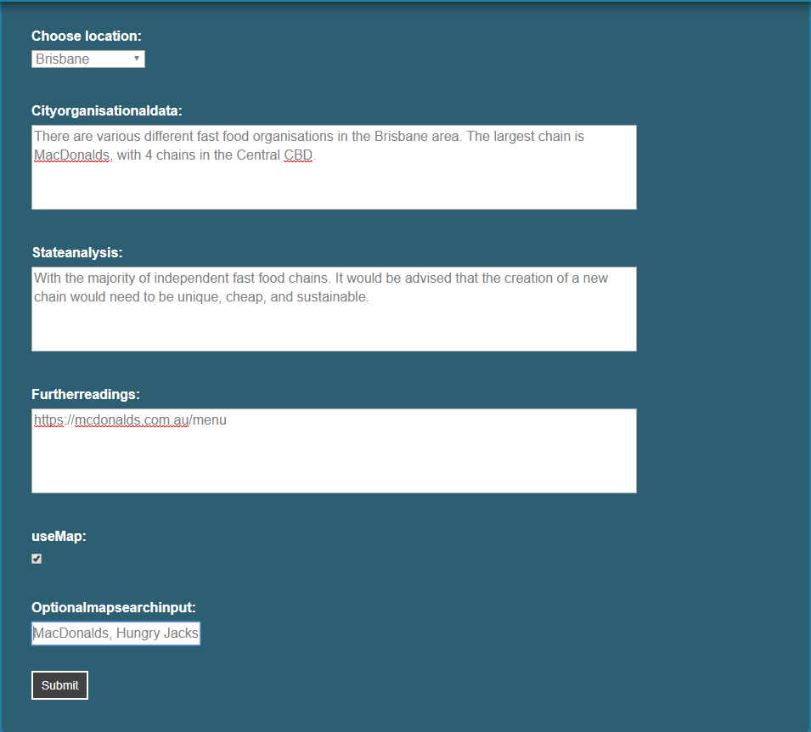

The important area to note is the Optional Map Search Input. If used, they must be different things to search for in the location selected above, separated with just a ‘,’.

# Create Locations:

* Change locations in the <http://127.0.0.1:8000/admin/> section under the ‘Feature location models’

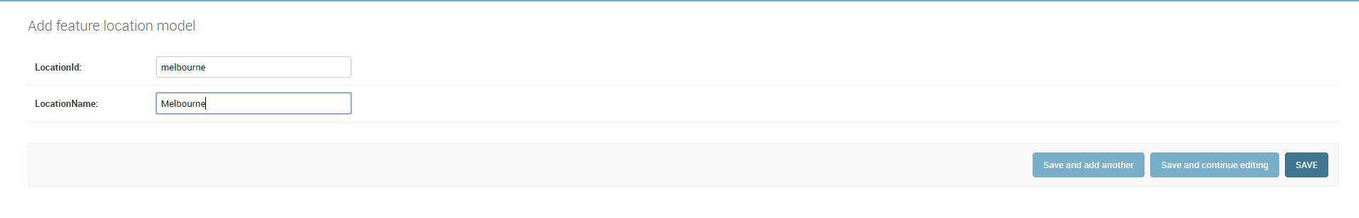

* The Location ID is the location that is searched in google, and the Location Name is the name that is displayed to the user, if the admin wants these to be different.
  + Be sure not to have spaces in these entries.

# Edit Map Checkboxes:

* To edit the displayed checkboxes to users in the Map page. Do so in the <http://127.0.0.1:8000/admin/> section under the ‘User type access models’
  + The ‘cityInfo’ model affects all users
  + ‘student’ affects students
  + ‘tourist’ affects tourists
  + ‘businessman’ affects businessmen
* 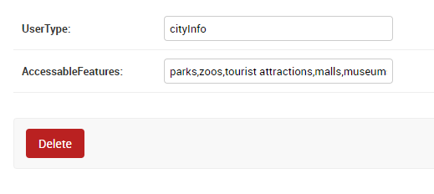
  + The ‘AccessableFeatures’ are what displays to the user.
  + They should be separated by ‘,’ with no unnecessary spaces